**CHURN ASSIGNMENT**

BY QADIR BUX

Included a new column into the dataset by the name of Customer Status and used the value from churned column to findout which customers churned and retained.

And also added new columns to Encode categorical variables but couldn’t identify how to used them in visualization

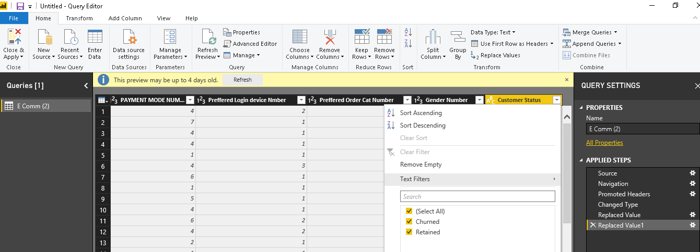

Removed Blank/Null values from the OrderCount Column

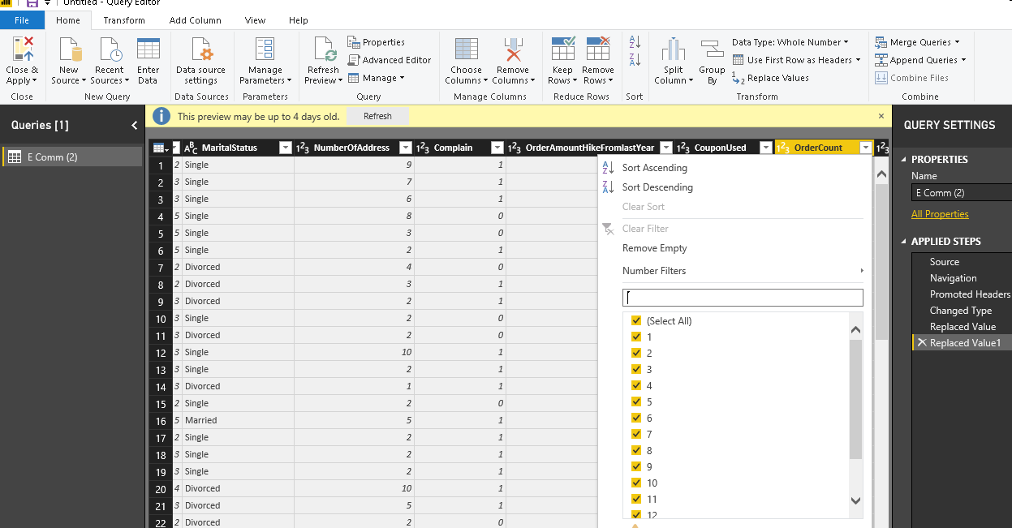

Replaced Null values in the column of CouponUsed by 0.

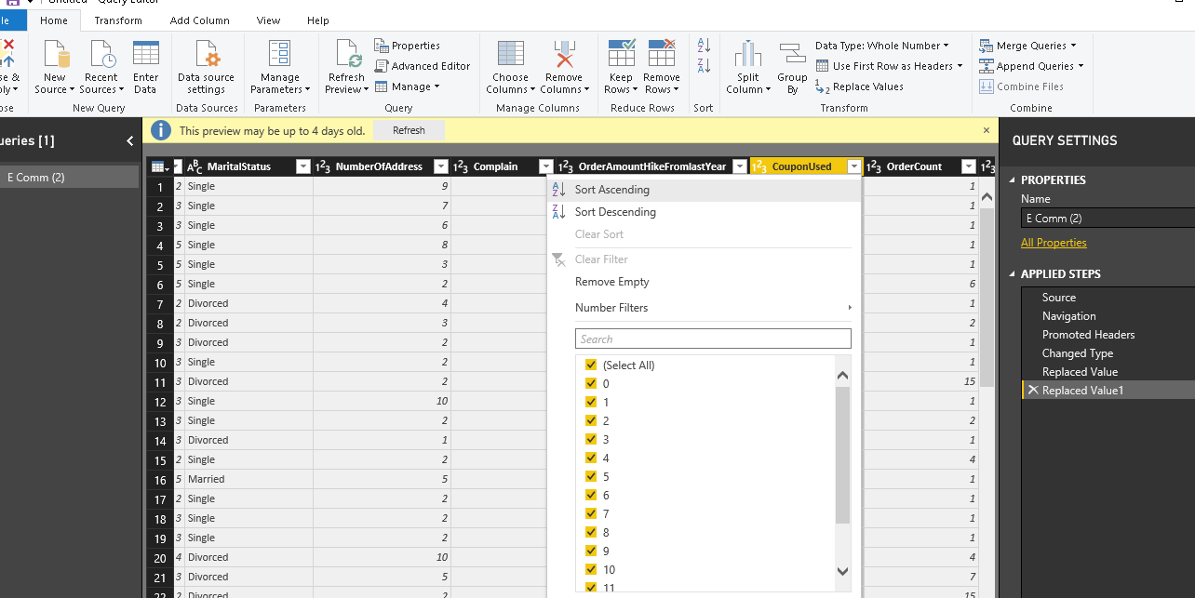

Used Find and replace feature to find CC which was abbrevation of Credit card and COD which was abbreviation of Cash on Delivery By their Full Form.

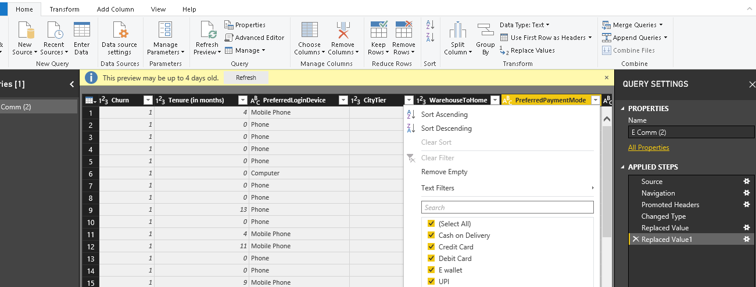

Made Dashboard Consiting information regarding Churned and Retained Customers Percentage along with their Avg Satisfaction score, Avg ordercount, Avg distance and Avg City Tier to provide the overall view of the customers.

Added Visualization of Preffered Device where Mobile phones was used the most both by Churned And Retained Customers

Added Visuals of Avg tenure By Retained and Churned Customers where Avg tenure of Retained Customers was relatively quite high than churned Customers

Added visuals of AVG Satisfaction score And AVG complain by Customers Retained and Churned and found out the satifaction score of Customers Churned was high and one of the main reason was their Avg Complain was high compared to Retained Customers

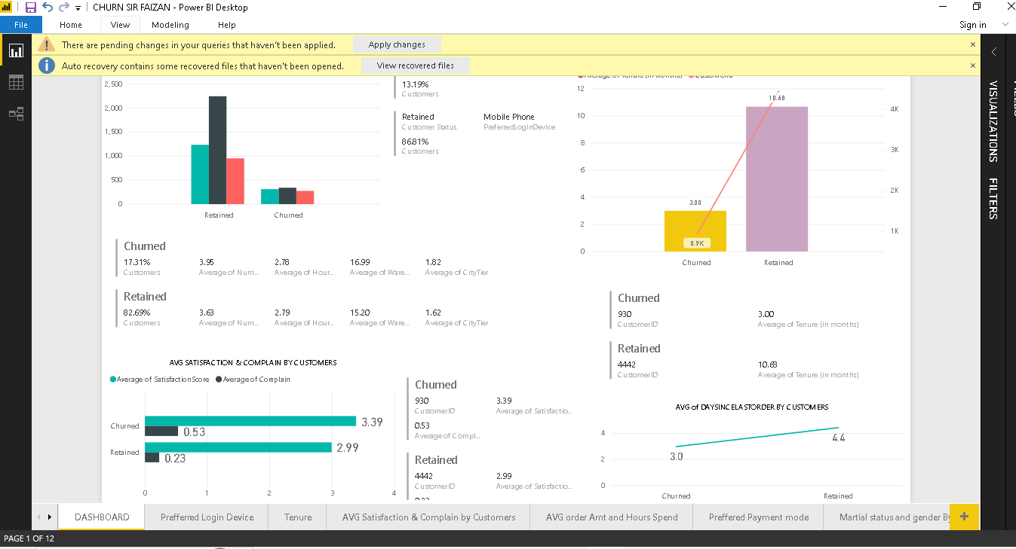

Included the Visuals of Preffered Login Device By Customers Status and found Mobile app was the preffered login device in both Retained 86.81% and Churned 13.19% Customers Following Computer and Phone

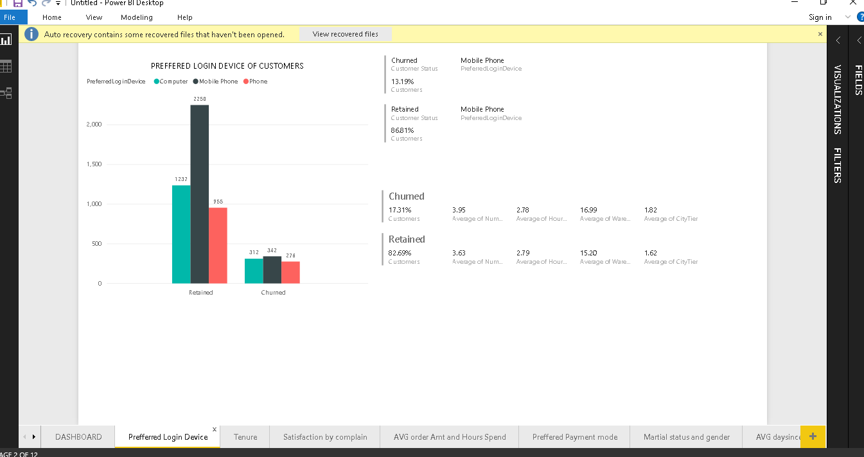

Created visuals as per Assignments Requirement of AVG tenure by Customers Status whose result show that The average Tenure of Retained Customers was very high than Churned Customers.

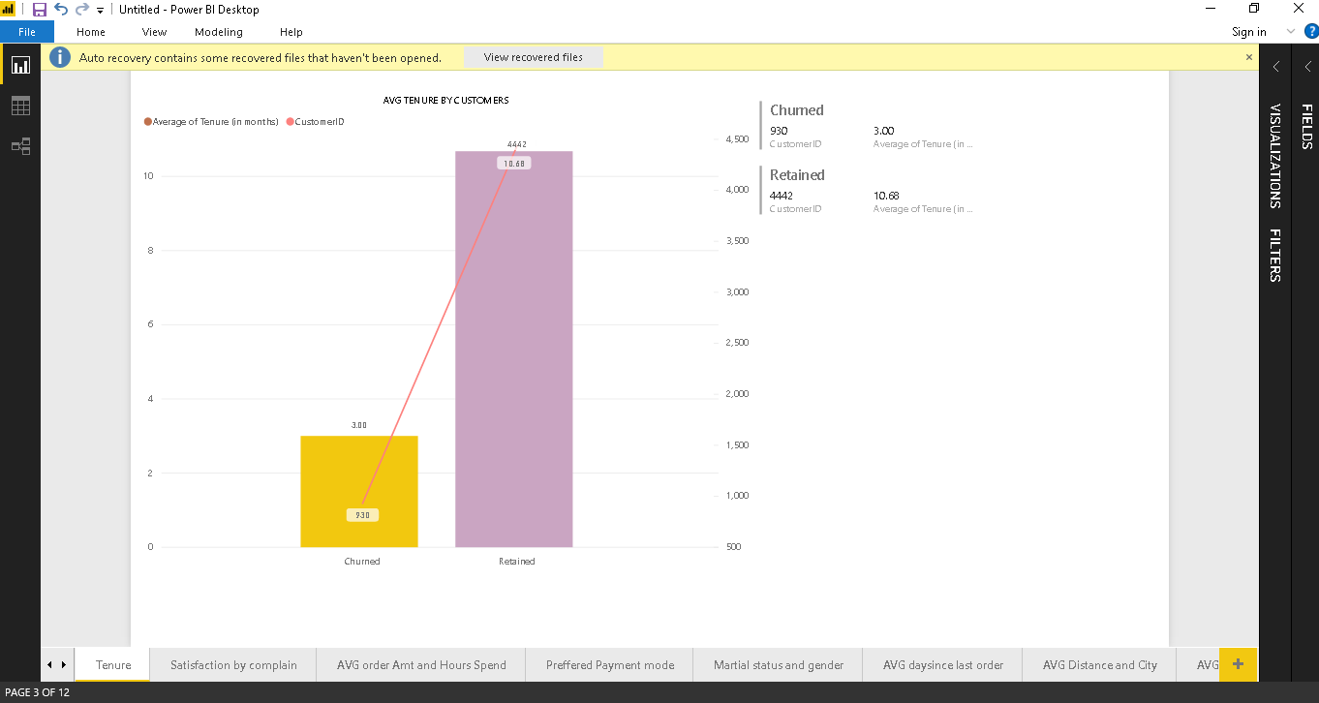

After coming across what was the reason of surprised data of AVG satisfaction score of Churned Customers being high than Retained Customers. I found out the main reason was the complains as the AVG complain was twice as much as of Retained Customers which must be the reason why churned customers had high satisfaction score

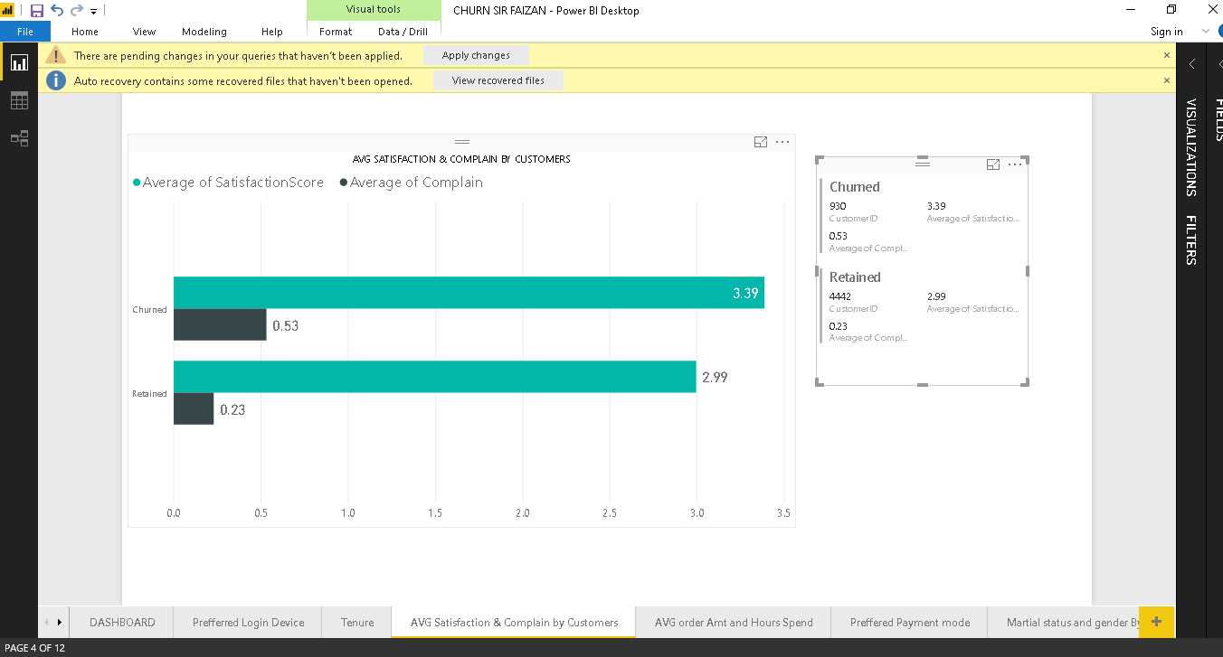

These are the visuals of AVG orderCount and AVG Hour spent on app by customer status and found out that AVG ordercount of Retained was high and in AVG hour spent on app but by small margin.

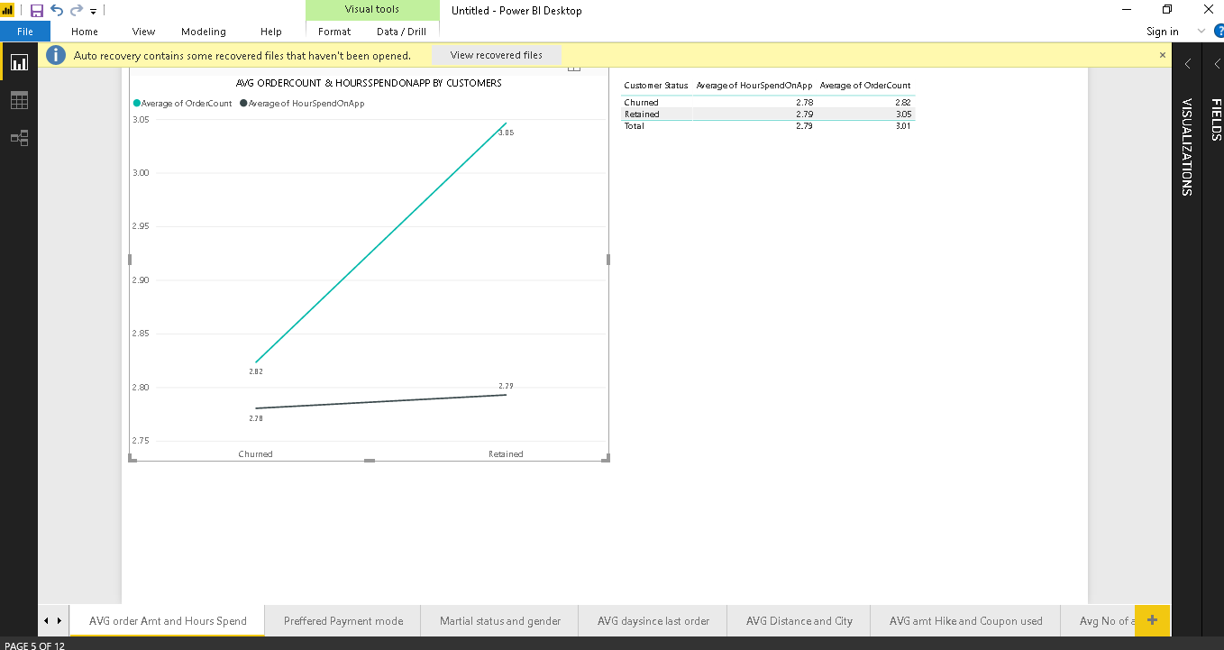

These are the visuals of Preffered By Payment Mode by Customers Status in which Debit Card is used the most by both customers followed by Credit Card, E wallet, Cash on Delivery and UPI

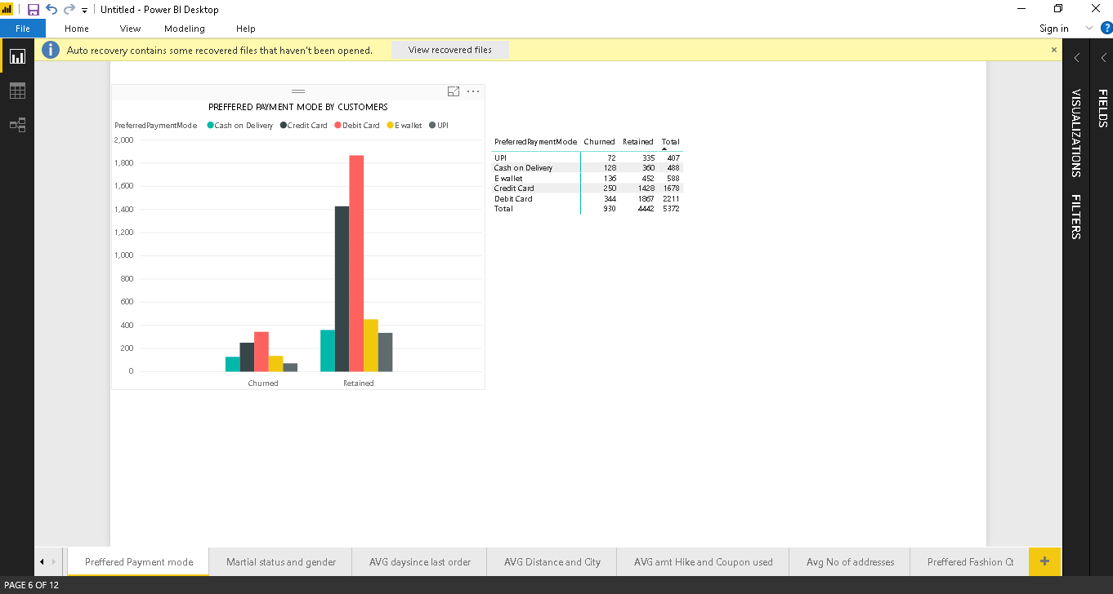

Created Visuals of Genders by Customers Status where Customers were retained as almost 50% of the customers. Males should be targeted more as they are our main customers accounting for almost 60% including Churned and Retained Customers

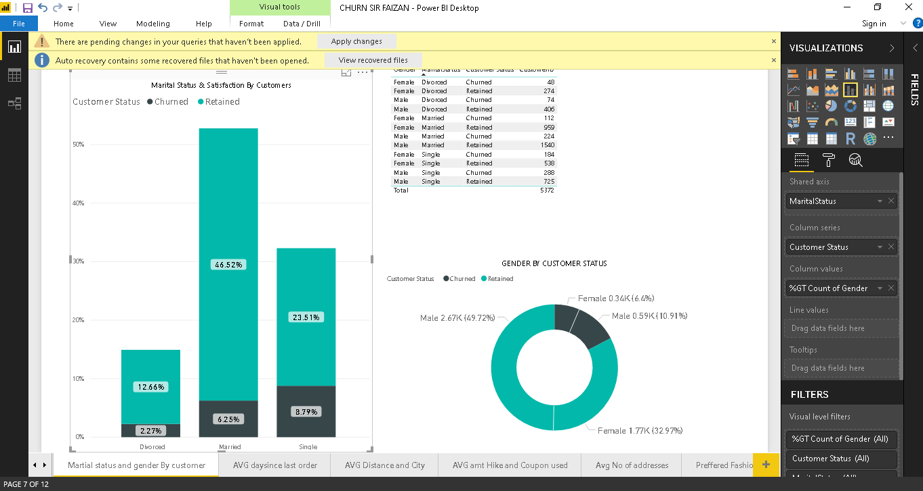

Included Visuals of AVG DaySinceLast Order by Customers Status where AVG daysincelastorder was high of retained customers than churned customers but order count of retained customers was high.

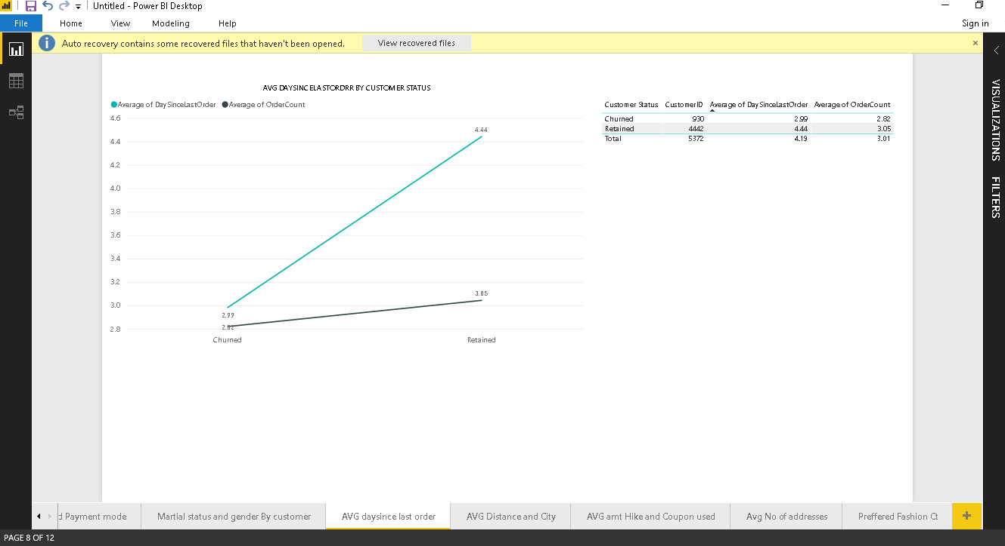

The average distance from warehouse was high of Churned Customers compared to Retained Customers which can be one of the reason why they churned.

Secondly, Another reason can be the average city tier of churned customers was high which can be one of the reason why they churned as their location might have more options for them to buy from.

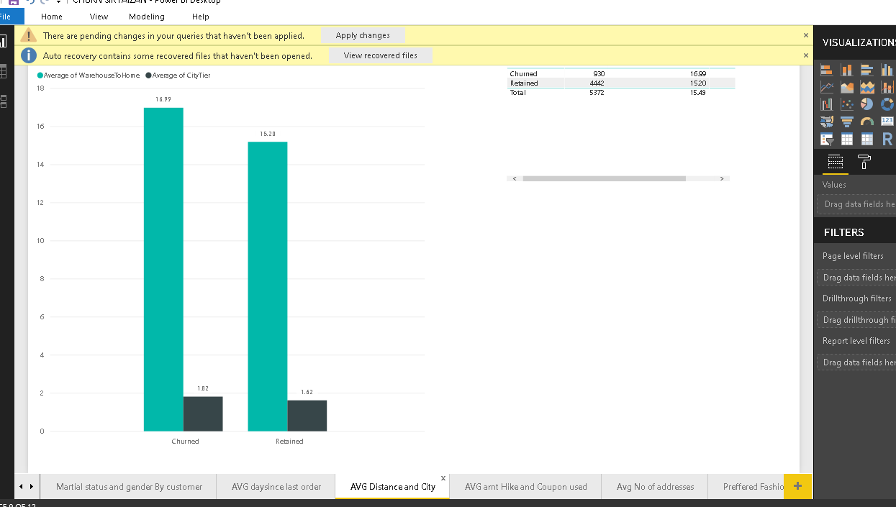

AVG amount hike is almost equal of both the customers which means the customer churned has nothing to do with amount hike. There can be other reasons

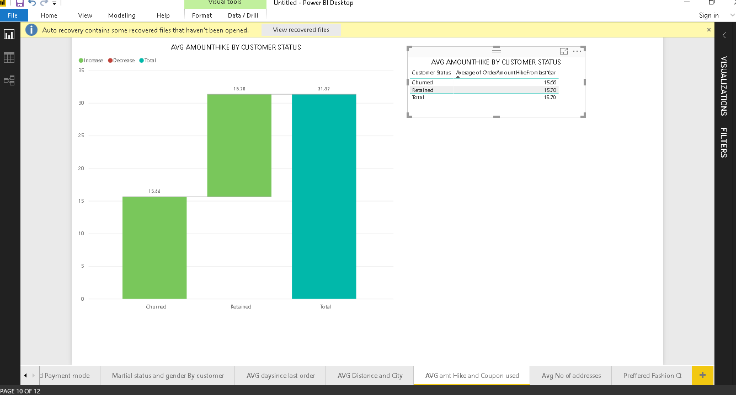

AVG no of address by gender of retained male is low compared to churned male while retained female is high compared to churned female.

AVG no of address of divorced, married and single is high in Churned

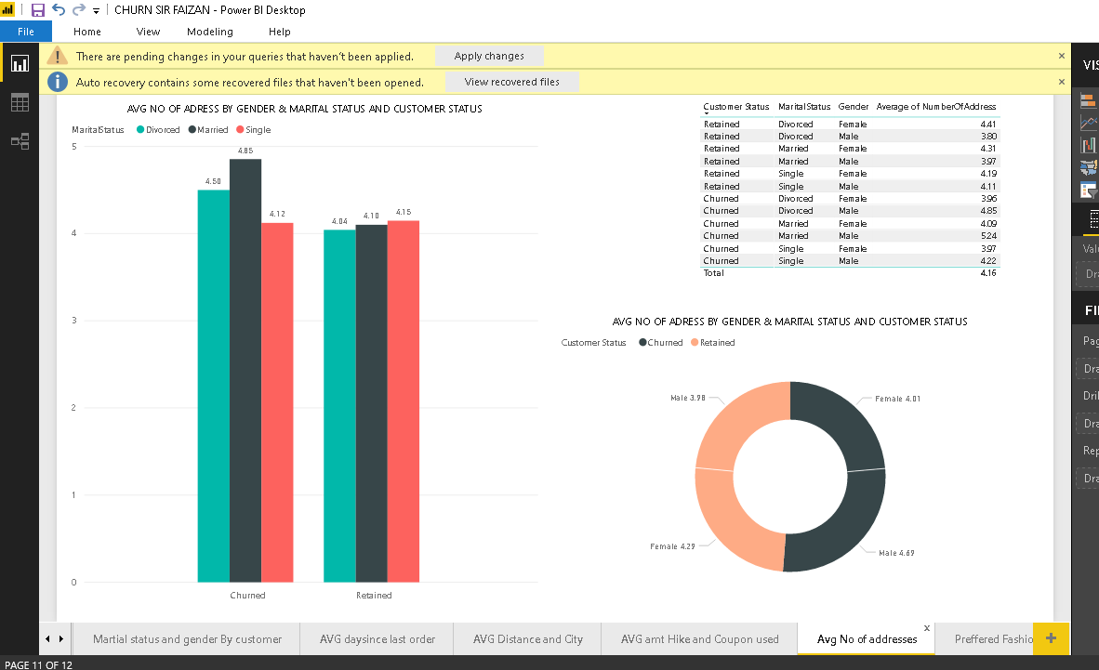

The most preffered Category among retained customers is laptop and accessory while among churned customers is mobile phone

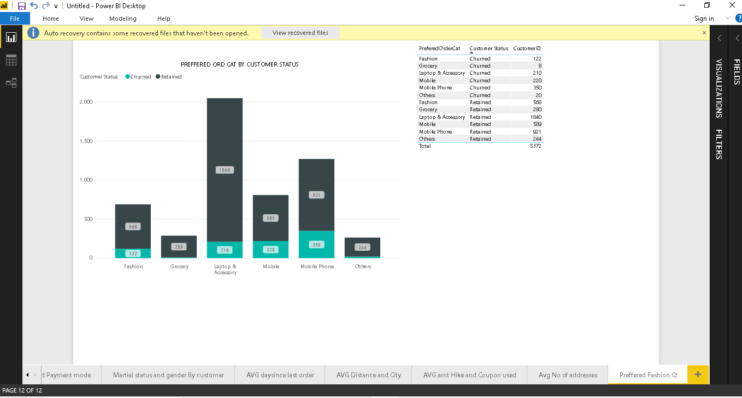

INSIGHTS

* Mobile app was the preffered device among retained 86.81% and churned customers 13.81%.
* AVG tenure of Retained Customer was very high with 10.69 while Churned Customer had 3.00
* AVG Satisfation of ChurnedCustomers was high with 0.53 and Retained Customer with 0.23 which is because the AVG Complain of Churned was 3.39 and Retained was 2.99
* Retained Customer and Churned customer had same amount of time spent on app but the order count of retained was high with 3.05 while churned customers had 2.82
* Debit Card was the most preffered Payment mode used in both retained and churned customers.
* Males are our main customers with retained 50% and 10% churned
* More specifically Married Males were retained with 32.%
* AVG Day since last order was 4.44% of Retained customers and their order count was 3.05
* AVG distance to ware house was high of churned customers and also their AVG City tier was high too
* AVG Amount Hike since Last year of both Retained and churned Customers was almost same
* In Preffered order category Laptop and Accessory were sold the most by retained customers

RECOMMENDATIONS:

* Company should make the mobile app more user friendly and more appealing so that the remaining 13% churned must not churn
* Company must engage their customer and make strategies so that customer stays for longer period their chances of retaining customers can increase or they might find out why customers churns within 3 months and improve that
* They must keep offers on debit cards and credit card as they are the preffered payment modes
* They must engage their customers by getting feedback so that they can know what is wrong in them as everyone does not complain instead they churn so the better strategy is to get feedback from them
* Target Males as they are our main customers and introduce more products in male category more specifically married males